Mehta Coffee Shop

(A Website to order delicious and refreshing Coffee)

A PROJECT REPORT

Submitted by

Rishu Ranjan
To
Mrs. Gauri Thakur
(Asst. Professor)

in partial fulfilment for the award of the degree
of

BACHELOR OF TECHNOLOGY

IN

COMPUTER SCIENCE ENGINEERING



Lovely Professional University, Punjab

12414614

OCTOBER 2024

Mehta Coffee Shop

(A website where people can order delicious and refreshing coffee.)

A PROJECT REPORT

Submitted by

Rishu Ranjan
(12414614)

in partial fulfilment for the award of the degree of

BACHELOR OF TECHNOLOGY



Lovely Professional University, Punjab

OCTOBER 2024

Lovely Professional University, Punjab

BONAFIDE CERTIFICATE

Certified that this project report is the Bonafede work of Rishu Ranjan(12414614)
who carried out the project work under my supervision.

SIGNATURE

CLASS MENTOR

HEAD OF THE DEPARTMENT

SIGNATURE

SIGNATURE
SUPERVISOR

Student Declaration

I, Rishu Ranjan(12414614) hereby declare that the work done by me on “HTML & CSS” from 05/10/2024 to 25/10/2024, is a record of original work for the partial fulfilment of the requirements for the award of the degree, B.Tech (CSE).
Rishu Ranjan(12414614)
Dated: 18/10/2024.

TABLE OF CONTENTS

CHAPTER  NO. | CHAPTER NAME | PAGE NO.
 | Title Page | i
 | Bonafide Certificate | ii
 | Student Declaration | iii
 | Table of Contents | iv
1 | Introduction | v
2 | Objective | vi
3 | Features & technologies used | vi-x
4 | Website Architecture & Challenges and Solution | x-xiii
5 | Code & Output | xiii-xxvii
6 | Appendices and Features | xxviii-xxxiii

Project Title: Coffee Shop Website
Objective
The goal of this project is to design a website for a coffee shop that effectively showcases its brand, menu, and story. It aims to attract coffee enthusiasts by providing a user-friendly and visually appealing interface where they can explore coffee options, learn about the shop's story, and connect with the business.
Technologies Used
- HTML5: For structuring the content on the webpage.
- CSS3 (via an external stylesheet named 2style.css): For styling and designing the webpage to enhance the user experience.
- Responsive Design: Ensures compatibility across various devices, achieved through meta tags and responsive CSS.
Project Structure
- Header and Navigation Bar
  - Contains a logo and navigation links to various sections, such as Home, About, Menu, and Contact.
  - Enhances user accessibility and helps with navigation across the website.
- Main Header Section
  - Displays a large, inviting title: "Start Your Day with Our Coffee," along with a "Shop Now" button that encourages users to explore products.
  - Serves as the primary branding area and provides a call-to-action to engage visitors.
- Our Story Section
  - Provides a brief introduction to the coffee shop’s journey and passion for coffee, allowing customers to connect with the brand.
  - Includes an image section and a button for users to learn more about the coffee shop's background.
- Perfect Place to Enjoy Coffee Section
  - Highlights the ambiance and experience of enjoying coffee in different settings like a library nook or garden patio.
  - The section contains a descriptive paragraph and an image, creating a cozy and inviting atmosphere.
- Products Section
  - Features cards displaying various coffee options, such as Mocha, Americano, and Affogato, each with a description of ingredients.
  - Each card has an image, a short description of ingredients, and a "Learn More" button, inviting visitors to explore product details.
- Footer
  - The footer is divided into three parts:
    - About Us: Gives an overview of the coffee shop's passion for quality coffee.
    - Contact Us: Provides the location, contact number, and email for customer inquiries.
    - Opening Hours: Mentions the coffee shop's style and ambiance, attracting the target audience.
Key Features
- Responsive Design: The website is optimized for different screen sizes, providing a consistent experience on desktops, tablets, and mobile devices.
- Product Cards: Displays coffee options with images and a list of ingredients, giving users a quick overview of the menu items.
- Branding Consistency: The consistent use of branding elements (colors, fonts, and buttons) throughout the site reinforces the coffee shop’s identity.
- Social Media Integration: Although not fully implemented here, the structure supports easy additions for social media icons and links to increase engagement.
Future Enhancements
- E-commerce Integration: Adding a shopping cart and online ordering system would allow users to order coffee and other products directly from the website.
- Testimonials and Reviews: Adding a section for customer reviews could boost credibility and engage new users.
- Newsletter Subscription: A subscription form would help the coffee shop build a mailing list for promotions and news.
Conclusion
This project demonstrates a basic yet functional coffee shop website that is visually appealing and user-friendly. The design is tailored to reflect the coffee shop's ambiance and brand while also offering essential information and an easy navigation experience for users.

Homepage:
<html lang="en">
<head>
<meta charset="UTF-8" />
<meta http-equiv="X-UA-Compatible" content="IE=edge" />
<meta name="viewport" content="width=device-width, initial-scale=1.0" />
<title>Coffee</title>
<style>
.logo {
width: 150px; /* Fixed width */
height: 100px; /* Fixed height */
}

:root {
--main-color: #deab5f;
--primary-color: #312e2e;
}

/* Utility Styles */
button {
padding: 10px 30px;
background: var(--main-color);
border: none;
cursor: pointer;
}

* {
padding: 0;
margin: 0;
box-sizing: border-box;
}

body {
background: #100e0f;
}

nav {
display: flex;
justify-content: space-around;
align-items: center;
color: #fff;
font-family: sans-serif;
padding-top: 15px;
}

li {
display: inline;
list-style: none;
}

li a {
color: #fff;
text-decoration: none;
margin-left: 40px;
}

li a:hover {
border-bottom: 2px solid #deab5f;
}

.header {
background: url("pexels-nao-triponez-129207.jpg");
background-position: center;
background-size: cover;
height: 100vh;
font-family: "Playfair Display SC", serif;
font-weight: normal;
display: flex;
flex-direction: column;
justify-content: center;
align-items: center;
color: #fff;
position: relative;
text-align: center;
}

.main-headings {
position: absolute;
top: 7rem;
font-size: 4rem;
word-spacing: 10px;
}
.primary-heading {
position: absolute;
bottom: 4rem;
font-size: 4rem;
word-spacing: 10px;
margin-bottom: -40px;
}

.main-btn {
position: absolute;
bottom: 2rem;
padding: 10px 30px;
margin-top: 20px;
background: transparent;
background: var(--main-color);
border: none;
cursor: pointer;
transform: translateY(60px);
}

#our-story {
margin-top: 15%;
display: flex;
flex-wrap: wrap;
justify-content: space-around;
align-items: center;
}

.img {
width: 400px;
height: 400px;
background: url(pexels-chitokan-2183027-removebg-preview.png);
background-position: center;
background-size: cover;
}

.title-style {
display: flex;
align-items: center;
}

.title {
font-family: "Playfair Display SC", serif;
font-size: 4rem;
color: #fff;
transform: translateX(-100px);
}

.line {
width: 100px;
height: 2px;
background: #fff;
transform: translateX(-120px);
}

.section-content p {
max-width: 500px;
color: #fff;
font-family: sans-serif;
line-height: 20px;
margin: 20px 0;
}

.coffee-container {
display: flex;
justify-content: space-around;
align-items: center;
flex-wrap: wrap;
margin-top: 10rem;
}

.content-section p {
max-width: 500px;
}

.img-container {
width: 500px;
height: 400px;
}

.img-2 {
width: 400px;
height: 400px;
}

.title-two {
font-size: 3rem;
color: #fff;
font-family: "Playfair Display SC", serif;
font-weight: normal;
}

.content-section p {
color: white;
margin-top: 20px;
font-family: sans-serif;
}

.products {
margin-top: 5rem;
}

.title-three {
font-size: 4rem;
margin-left: 10rem;
margin-top: 10rem;
margin-bottom: 10rem;
}

.cards {
display: flex;
flex-wrap: wrap;
flex-direction: row;
justify-content: space-around;
align-items: center;
}

.card {
border: 2px solid #deab5f;
padding: 0 20px;
height: 400px;
width: 300px;
display: flex;
flex-direction: column;
justify-content: space-around;
align-items: center;
border-radius: 5px;
position: relative;
margin-bottom: 4rem;
}

.card-img {
width: 100px;
height: 100px;
position: absolute;
top: -60px;
}

.img-one {
background: url(Images/1.png);
background-position: center;
background-size: cover;
}
.img-two {
background: url(Images/3.png);
background-position: center;
background-size: cover;
}
.img-three {
background: url(Images/4.png);
background-position: center;
background-size: cover;
}

.card-title {
color: #fff;
font-family: sans-serif;
margin-top: 50px;
}

.card .items p {
color: #fff;
margin: 20px 0;
font-family: sans-serif;
}

/* footer */
footer {
height: 50vh;
display: flex;
flex-wrap: wrap;
align-items: center;
justify-content: center;
color: #fff;
font-family: sans-serif;
}

footer .container {
margin: 20px;
max-width: 300px;
text-align: center;
}

footer .heading-info {
margin-bottom: 20px;
}

footer p {
line-height: 25px;
}

span {
color: #deab5f;
}

hr {
margin-bottom: 20px;
border-color: #deab5f;
width: 500px;
margin: 0 auto;
}

.para {
color: white;
font-family: sans-serif;
text-align: center;
margin-top: 20px;
}

@media only screen and (max-width: 768px) {
.main-headings,
.primary-heading {
font-size: 2.5rem;
}

#our-story {
text-align: center;
}

#our-story .title {
transform: translateX(50px);
}

#our-story .line {
display: none;
}

.content-section {
text-align: center;
}

#our-story .img-container .img {
width: 70%;
text-align: center;
margin: 0 auto;
}

.coffee-container .img-container {
margin-top: 5rem;
width: 50%;
}

hr {
width: 400px;
}

.hr-two {
display: none;
}

.para {
margin-top: 10rem;
}
}
</style>
</head>
<body>
<!-- nav -->
<nav>
<header>
<img src="rishu mehat logo.webp" alt="Your Logo" class="logo">

</header>

<ul>
<li><a href="#" class="active">Home</a></li>
<li><a href="#">About</a></li>
<li><a href="#">Menu</a></li>
<li><a href="#">Contact</a></li>
</ul>
</nav>

<!-- header -->
<section class="header">
<h1 class="main-headings">START YOUR DAY</h1>
<h1 class="primary-heading">WITH OUR COFFEE</h1>
<button class="main-btn">Shop Now</button>
</section>

<!-- our story -->

<section id="our-story">
<div class="img-container">
<div class="img"></div>
</div>
<div class="section-content">
<div class="title-style">

<span class="line"></span>
<h1 class="title">Our Story</h1>
</div>
<p>
Share your journey and passion for coffee.
</p>
<button>Learn More</button>
</div>
</section>

<!-- Perfect place to enjoy your coffee -->
<section class="coffee-container">
<div class="content-section">
<div class="title-style">
<h1 class="title-two">
Perfect Place <br />
To Enjoy Your <br />
Coffee
</h1>
</div>
<p>A balcony with a view, a quiet library nook, a beachside morning, a garden patio, or a rustic cabin.</p>
<button style="margin-top: 20px">Learn More</button>
</div>

<section class="img-container">
<img src="2 (1).png" class="2 (1).png" alt="" height="400" width="400"/>
</section>
</section>

<!-- Products -->
<section class="products">
<h1 class="title title-three">Products</h1>

<section class="cards">
<div class="card">
<div class="card-img img-one"></div>
<div class="card-title">
<h1>Mocha</h1>
<img src="1.png" class="1.png" alt="" height="200" width="200">
</div>
<div class="items">
<p>Espresso</p>
<p>Chocolate</p>
<p>Steamed Milk</p>
</div>
<button>Learn More</button>
</div>
<div class="card">
<div class="card-img img-two"></div>
<div class="card-title">
<h1>Americano</h1>
<img src="3.png" class="3.png" alt="" height="200" width="200">
</div>
<div class="items">
<p>Espresso</p>
<p>Dark Chocolate</p>
<p>Dark Milk</p>
</div>
<button>Learn More</button>
</div>
<div class="card">
<div class="card-img img-three"></div>
<div class="card-title">
<h1>Affogato</h1>
<img src="4.png" aria-colcount="4.png" alt="" height="200" width="200">
</div>
<div class="items">
<p>Espresso</p>
<p>Chocolate</p>
<p>Cow Milk</p>
</div>
<button>Learn More</button>
</div>
</section>
</section>

<!-- footer -->
<hr />
<footer>
<div class="container">
<h1 class="heading-info">About <span>Us</span></h1>
<p>
Coffee is a rich, aromatic drink enjoyed worldwide for its flavor and caffeine kick. Originating in Ethiopia, it comes in many varieties and is loved for its unique taste and energizing effects.
</p>
</div>
<div class="container">
<h1 class="heading-info">Contact <span>Us</span></h1>
<p>
Phagwara (near modeltown)144420
<P>Contact:-6207156342</P>
<p>email:-rishuranjanrfj@gmail.com</p>
</p>
</div>
<div class="container">
<h1 class="heading-info">Opening <span> Hourse</span></h1>
<p>
Think about your coffee shop’s style, vibe, and target audience. Whether it’s cozy, rustic, modern, or minimalist, your vision will guide every choice.
</p>
</div>
</footer>
<hr class="hr-two" />

<p class="para">
Copyright @ 2024 | Provided by <span> Rishu mehta </span>
</p>
</body>
</html>
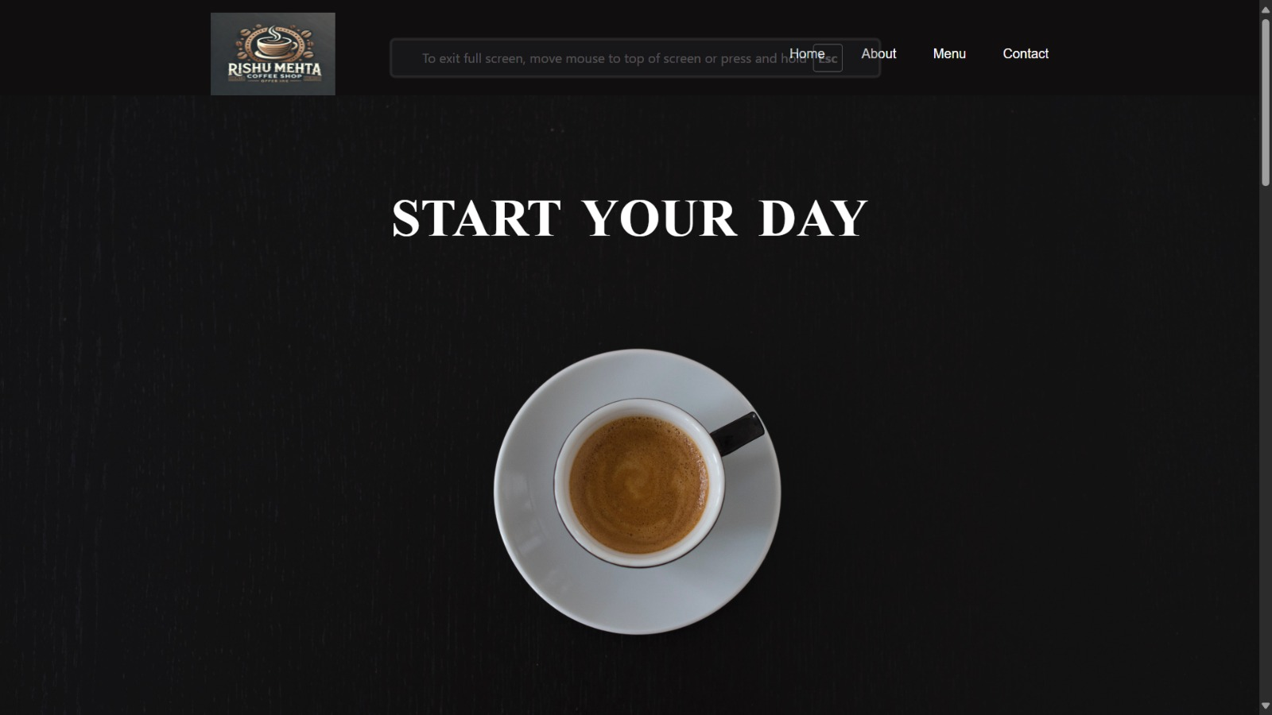
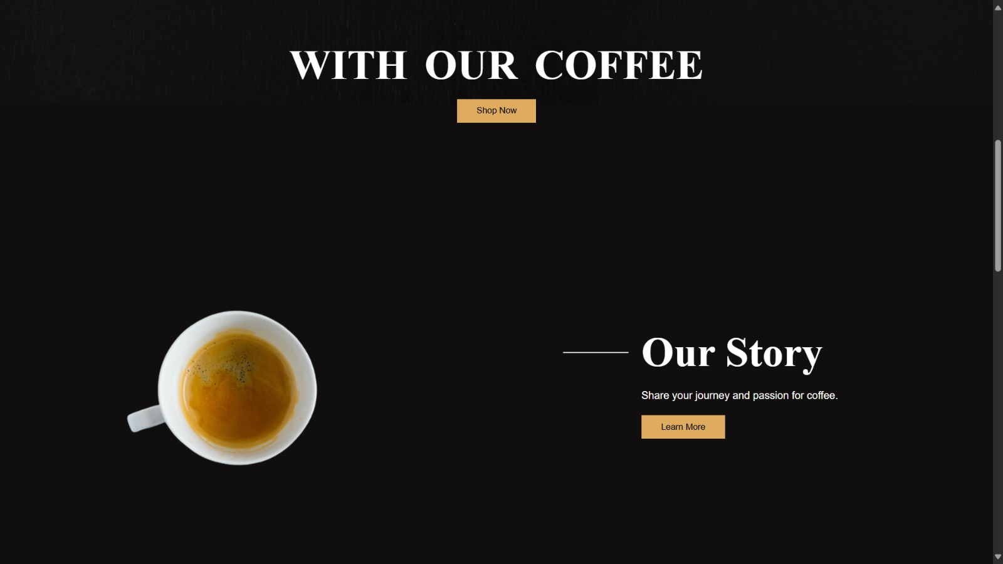

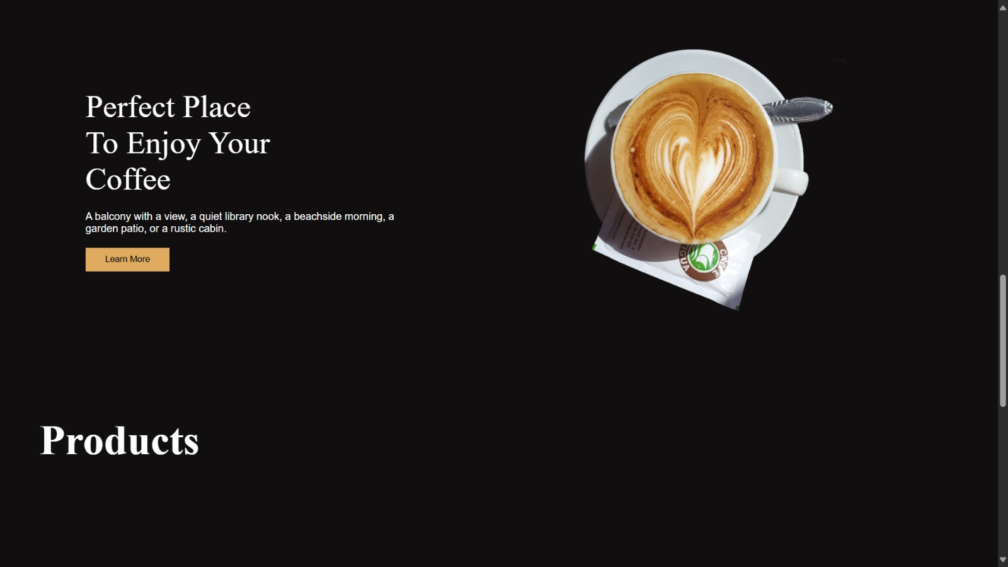

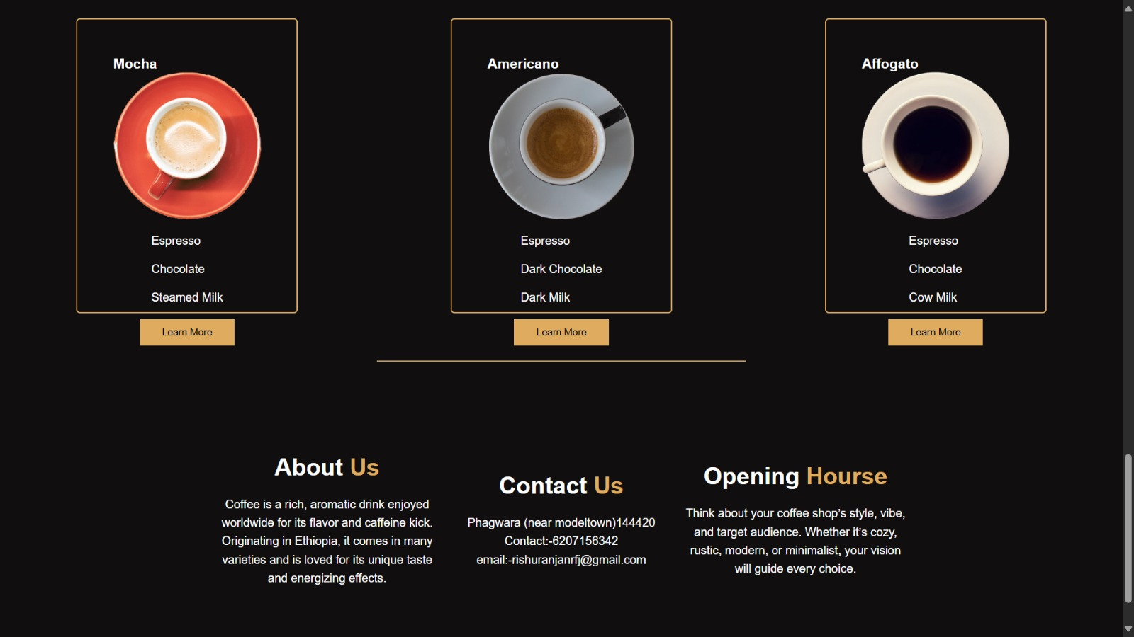

A.1 Purpose of the Website
The Coffee Shop website’s primary objective is to engage coffee enthusiasts by providing a visually appealing and easy-to-navigate platform. It allows users to explore coffee options, learn about the coffee shop’s story, and connect with the brand. The website also aims to simplify customer interactions, promoting transparency with clear product descriptions, customer reviews, and contact details.

A.2 Technological Framework
The Coffee Shop website leverages current web development technologies for a seamless user experience, security, and performance.
- Frontend: Built using HTML, CSS, and JavaScript with responsive design, ensuring compatibility with desktops, tablets, and mobile devices.
- Hosting: Hosted on a cloud platform, such as AWS or Google Cloud, with GitHub for version control, facilitating code collaboration and updates.
- Backend: Developed using Node.js and Express.js for handling server-side logic and potential integrations for future features.
- Database: Uses Firebase or MongoDB for securely managing user profiles, orders, and feedback.
- APIs: Integration with Google Maps API to assist customers in finding the shop’s location with ease.

A.3 Key Features
- Responsive Design: The website is optimized for various screen sizes, providing a consistent and engaging experience on all devices.
- Product Display: Coffee options are presented in visually attractive cards with details and ingredients, helping customers make informed choices.
- Customer Profiles: Users can create accounts to save favorite products, track orders, and receive personalized recommendations.
- Customer Review System: Allows customers to leave reviews, helping others make informed decisions and increasing trust in the brand.
- Learn More Buttons: "Learn More" links on the product cards and sections provide users with detailed information about each offering and the coffee shop’s story.

A.4 Intended Audience
The Coffee Shop website caters to a wide audience, including:
- Coffee Enthusiasts: People passionate about trying different coffee options and learning about coffee culture.
- Remote Workers: Individuals looking for a cozy coffee shop to work from, likely drawn to the shop's ambiance and menu.
- New Customers: Users discovering the shop for the first time who are interested in learning about the offerings.
- Locals and Tourists: Individuals seeking a unique coffee experience or a place to relax while visiting the area.

A.5 Accessibility Features
The Coffee Shop website is designed with accessibility in mind to ensure that all users can navigate and engage with the content.
- Screen Reader Compatibility: The site structure and image alt text make it easy for screen readers to interpret content, improving accessibility for visually impaired users.
- Color Contrast: High-contrast colors are applied to important text and buttons to ensure readability for those with visual impairments.
- Keyboard Navigation: Fully navigable through keyboard controls, supporting users who cannot use a mouse.
- Clear Language: Simple language is used throughout, making the site approachable for all reading levels.

A.6 Potential Enhancements
- E-commerce Functionality: Adding online ordering capabilities and a shopping cart to allow users to place orders directly through the website.
- Customer Loyalty Program: A reward program to offer discounts or perks for frequent customers, enhancing customer retention.
- Newsletter Subscription: A subscription form for customers to receive updates on new products, promotions, and events.
- Mobile App: A dedicated mobile application to give customers a more personalized and direct way to place orders, track orders, and view rewards.
- Social Media Integration: Links to social media profiles and a live feed to boost engagement and keep customers updated.

Conclusion
The Coffee Shop website is designed to be an engaging and customer-friendly platform for coffee lovers. As the website continues to develop, features like online ordering, loyalty programs, and a mobile app will enhance its usability, making it a go-to resource for coffee enthusiasts. By focusing on a warm, inviting design and emphasizing ease of navigation, the Coffee Shop website aims to establish a strong connection with users, driving brand loyalty and customer satisfaction.

References
- W3Schools – Resources for frontend development with HTML, CSS, and JavaScript.
- GitHub – Version control and collaboration platform.
- Google Maps API – Provides geolocation services for locating the coffee shop.
- Node.js Documentation – Backend functionality for potential server-side logic.
- Firebase Documentation – Database management for securely storing user information.

